Game Design Document
Fill up the following document

- Write the title of your project.
Cycle of Life

- What is the goal of the game?
To depict the reality of life

- Write a brief story of your game.
The game is an open world 2D game. The player will move around a
Forest (forest depicts life) in search of meaning of life. But the player

donesn’t know what is right and what is wrong. In our life, we don’t know what is our purpose. In this game, the player will search for this

purpose in his/ her life.

- Which are the playing characters of this game?
- Playing characters are the ones who respond to the user based on the input from the user.
- Cars, monkeys, dinos, wizards, etc., are the playing characters in the game.

Number | Character Name | What can this character do?
1 | Human | Move around
2
3
4
5
6
7
8

- Which are the Non-Playing Characters of this game?
- Non-Playing characters are the ones that don't have an action or behavior when the user interacts with the game.
- Hurdles, stones, bananas, coins, etc., are non-playing characters in the game.

Number | Character Name | What can this character do?
1 | Life | Background of game
2 | trees | Supporting in background
3 | river | Supporting in background
4
5
6
7
8

Draw your imagination of this game. What does this game look like?
- Draw the game either on your computer or on paper.
- Add images of the game scenes to show each of the playing and non-playing characters at least once.
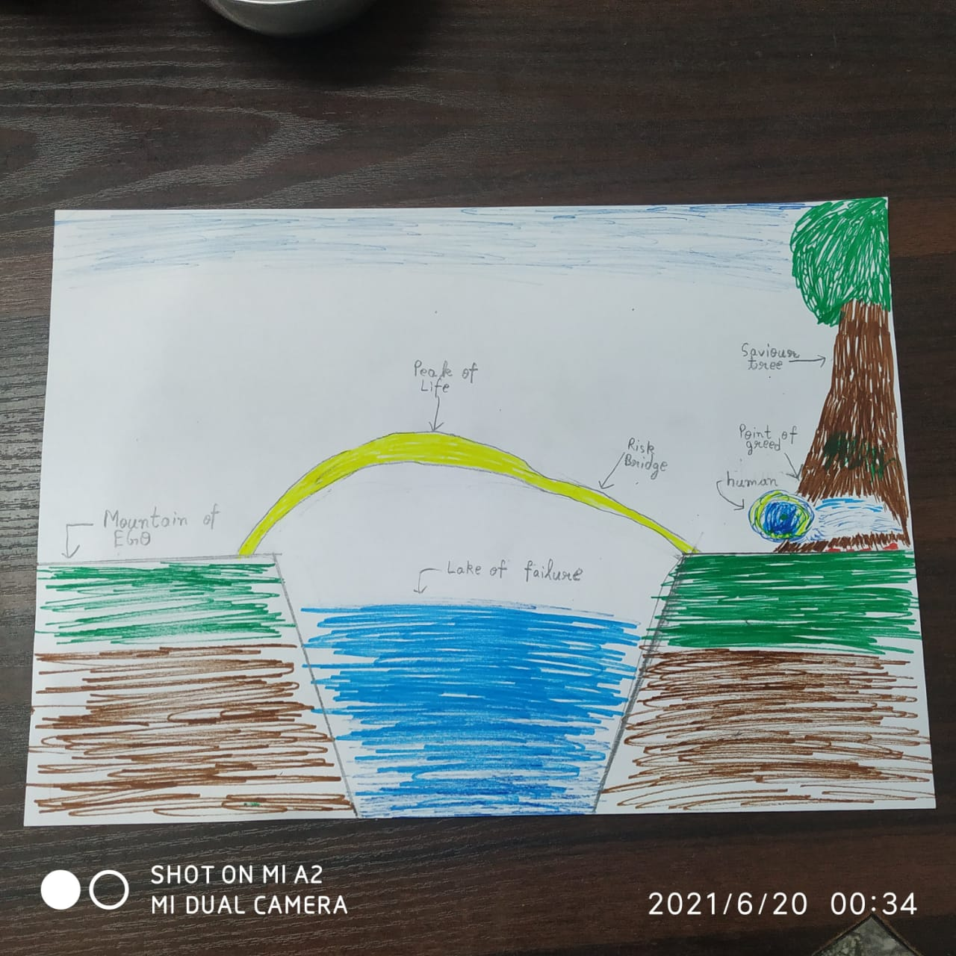
Zoom-in photos below:-
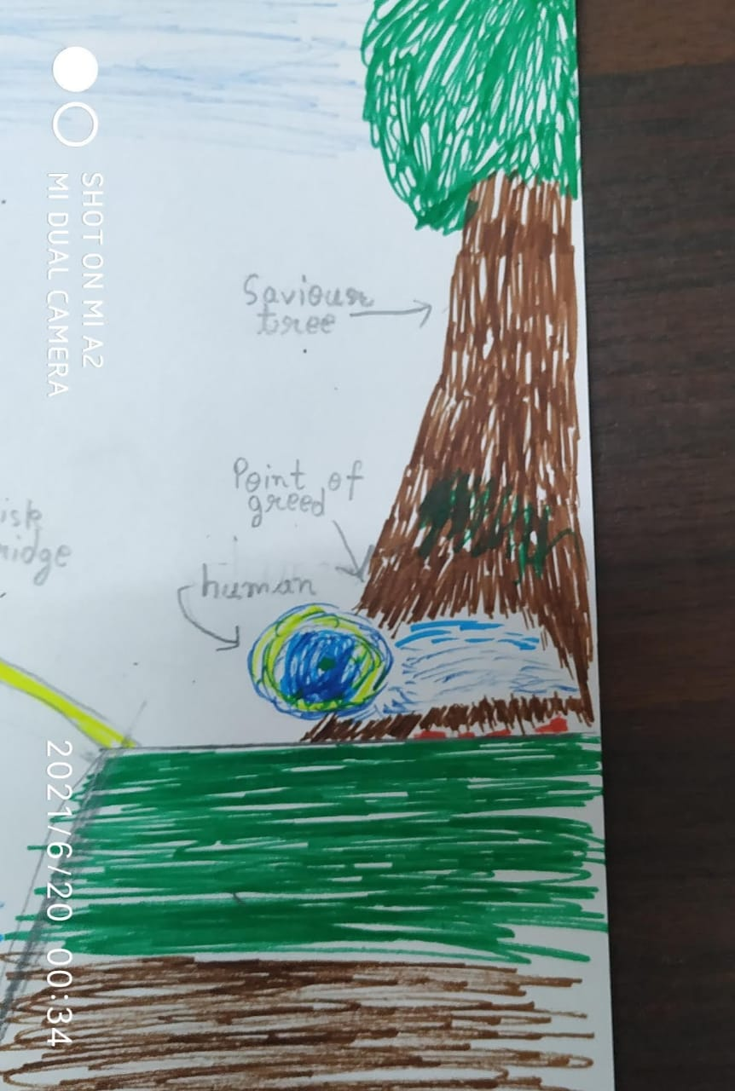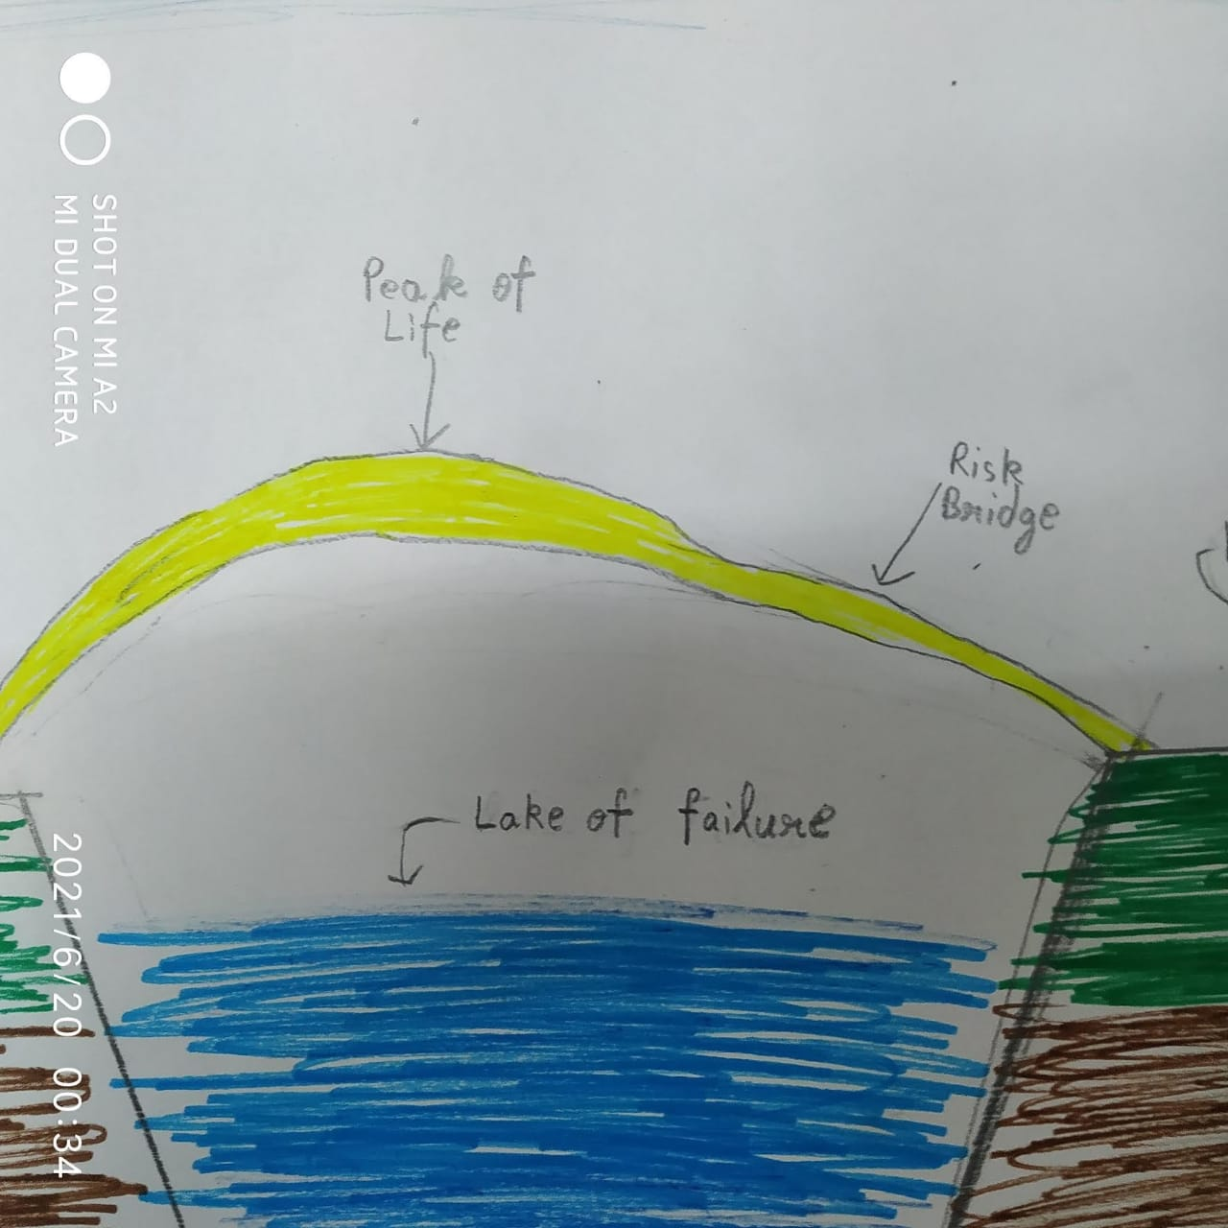
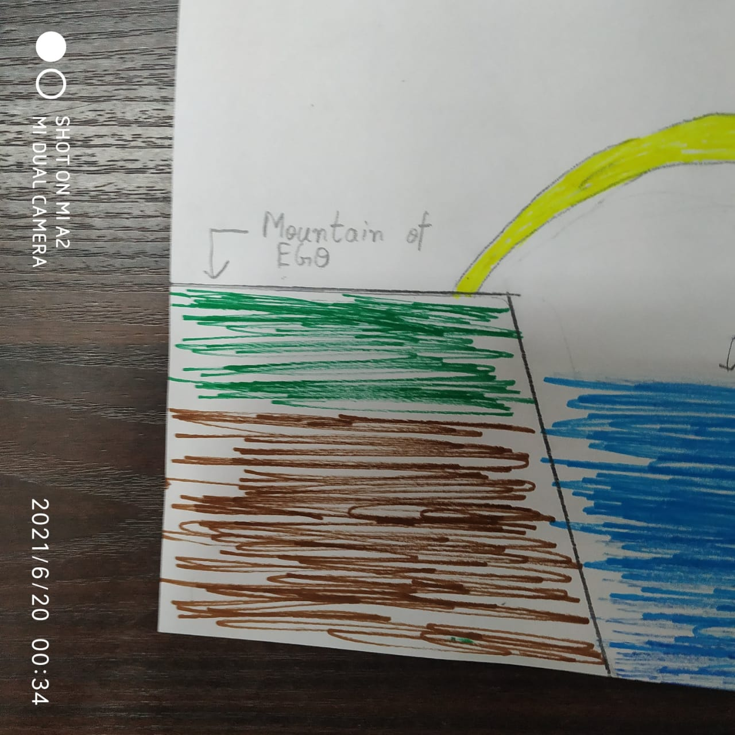

How do you plan to make your game engaging?
The player will move around freely in an interesting and beautiful environment while searching for meaning of life. In the way, he will find different obstacles trying to destroy his life. The game will give the player knowledge about the importance of knowing true goal in life.
The story of game is an allegory.

+

